1. Sampling Distribution of a Proportion

In the last lecture we introduced the concept of a sampling distribution of sample means, i.e. the probability distribution that characterizes the fluctuation of means of samples drawn from the same population. There we considered continuous variables. Now we will see how the concept of a sampling distribution applies to a binary variable like true/false, male/female, success/failure etc.

This is called the sampling distribution of a proportion.

Example. A binary variable scored True/False (T/F):

Population: { T, T, F, T, F, F, T, F, T, T } (60% 'True', π = 6/10 = .6)
Sample 1: { T, T, F, F } (50% 'True', p = 2/4 = .5)

Rate of trait in population is π.
Rate of trait in sample is p.

Sampling. The repeated drawing of random samples of size n from a population. Here n = 4:

Population: { T, T, F, T, F, F, T, F, T, T} (60% 'True', π = 6/10 = .6)
Sample 1: { T, T, F, F } (50% 'True', p₁ = 2/4 = .5)
Sample 2: { F, F, T, F } (25% 'True', p₂ = 1/4 = .25)
Sample 3: { T, T, T, F } (75% 'True', p₃ = 4/4 = .75)
etc. …

The proportion of 'Trues' changes from sample to sample. By repeated sampling, we can construct an observed distribution of sample proportions:

{ p₁ p₂ p₃ … } = { .5 .25 .75 … }

If we considered all possible samples drawable from the population, the distribution of sample proportions (p) would be the sampling distribution of the proportion.

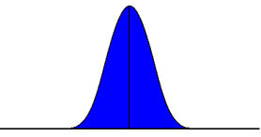
.5
Sampling Distribution of the Proportion (p)

Note that the sampling distribution of a proportion is closely related the binomial probability distribution we produced in a previous assignment.

The figure on the left (class assignment) is the probability distribution for the number of successes in a binomial experiment where k = 10 trials and p = .5. This is exactly the same as the probability distribution of the proportion of successes in samples of size k.

The sampling distribution of a proportion has a theoretical mean and standard deviation. The mean (expected value) is the same as the proportion of the event or trait in the population:
μ_{p} = π

The standard deviation of this distribution, or the standard error of the proportion is

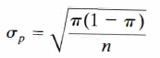

2. Normal Approximation of the Sampling Distribution of a Proportion

When the sample size n is sufficiently large, the sampling distribution of a proportion is well approximated by a normal (Gaussian) distribution. The usual rule-of-thumb is that
n π(1 – π ) ≥ 5 . [However, when p is near 0 or 1.0, a rule of π(1 – π ) ≥ 100 is safer.]

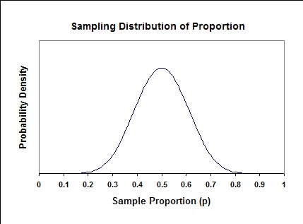 | π = .5, n = 20, nπ(1 – π ) = 5  Close to normal shape
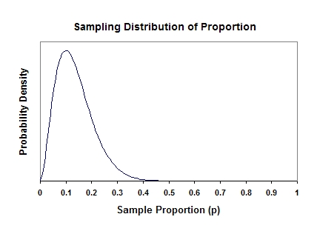 | π = .1, n = 10, nπ(1 – π ) = .9  Very skewed
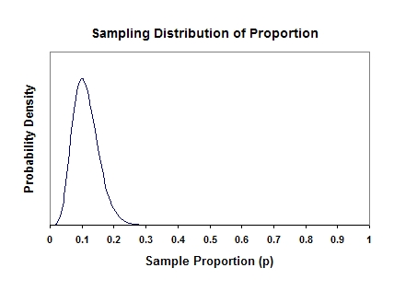 | π = .1, n = 60, nπ(1 – π ) = 5.4  Approaching normal shape

Because of the normal approximation, we can apply what we learned earlier about calculating areas under the standard normal curve to compute cumulative probabilities to draw certain inferences about sample proportions.

Example: the population proportion (π) of CDs that fail to meet specifications is 0.10. What is the probability that, in a random sample of 400 CDs, the proportion of defective CDs will be between 0.10 and 0.12?

1. Compute z-scores corresponding to 0.10 and 0.12.

1.1 Consult z-score formula:

 | (X – μ_{x} )
z = | –––––
 | σ_{x}
1.2 Plug in appropriate values:

X = p, μ_{x =} μ_{p} = π

so that:
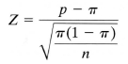

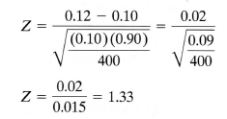

1.3 Determine area under standard normal curve from 0.10 to 1.33:

area = .9082

area=.5

Pr( 0.10 < p < 0.12) = area from z = 0.0 to z = 1.33

Area under standard normal curve from –∞ to 1.333 is 0.9082:
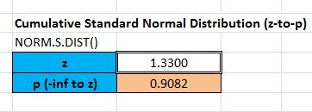

Area under standard normal curve from –∞ to 0 = 0.50.

0.9082 – 0.50 = .4082.

